welcome!
to the EUU Fall Retreat 2017 in Spa, Belgium
with Reverend Diane Rollert
“Engaging the Heart, Ways to Spirit”

and special guest Taco IJzerman, Druid

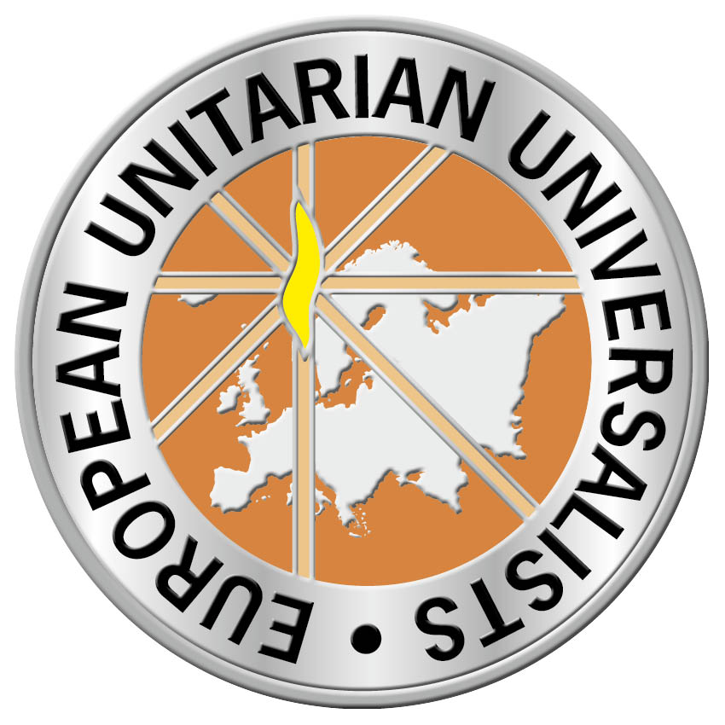

This retreat is sponsored by the
European Unitarian Universalist Association
and the Netherlands Unitarian Universalist Fellowship
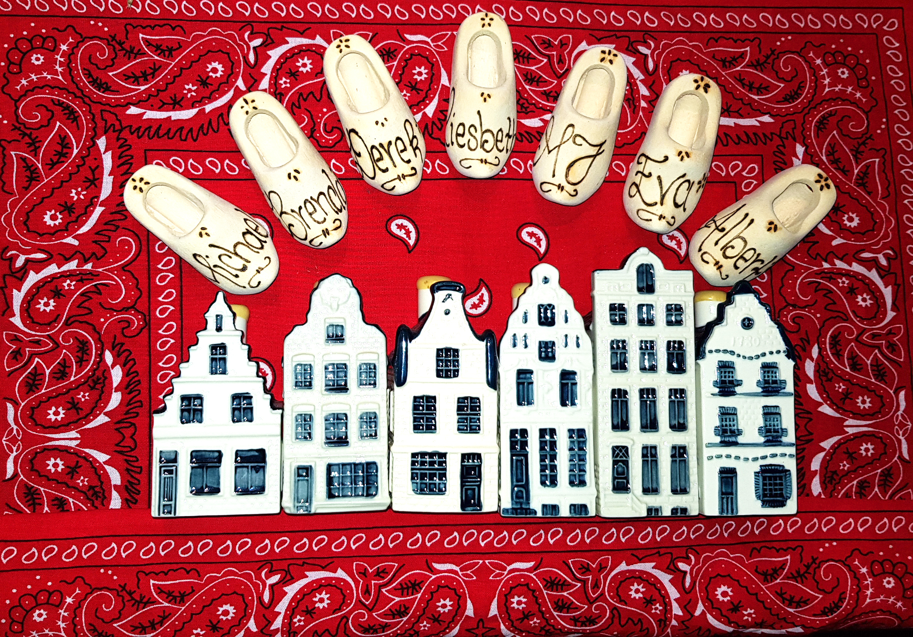

Welcome Pack Contents

4 Greetings and welcome to the EUU Fall Retreat 2017

5 About our Speaker: the Reverend Diane Rollert

6 About our Guest Speaker: Taco IJzerman

7 The Program

9 Workshops

13 EUU Membership Information

14 Join the EUU Pledge Drive/Unifier seeks contributors

15 Information on Vluchtelingenwerk

16 UU Principles and Sources

17 The EUU Team

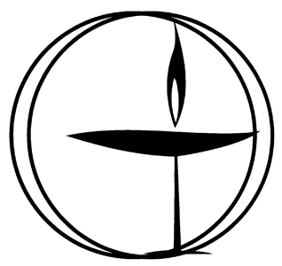
Greetings and Welcome to the EUU Fall Retreat 2017!

We are so happy that you are here with us. We are especially pleased to be returning to Sol Cress, a lovely location in the Ardennes forest that is one of our favorite retreat sites.

If this is your first retreat, a special welcome to you! We are looking forward to getting to know you. If you have questions about EUU or about Unitarian Universalism in general, please visit the Welcome Table or ask anyone for more information.

Those of us with red bandanas and wooden shoes around our necks are from NUUF, the Netherlands Unitarian Universalist Fellowship. Our fellowship has organized this retreat and we are here to help!

For the rest of you, whether this is your second retreat or your twenty-second, welcome back to your EUU home!

We would like to express our gratitude to our Keynote Speaker, Diane Rollert. Diane is the minister of the Unitarian Church of Montreal and the new UUA ambassador to the EUU! She will be speaking on "Engaging the Heart, Ways to Spirit."

We are also grateful to the EUU, without whom these retreat would not be possible!

We hope that this will be a transformative weekend for us all: a weekend of new and renewed friendships, a weekend of worship, fun, and inspiration!

With warm regards from all of us on the NUUF retreat Committee–
Eva Kortekaas, Rev. Derek Suchard, MJ Knoester, Brenda de Jong, Michael de Jong and Albert Manders

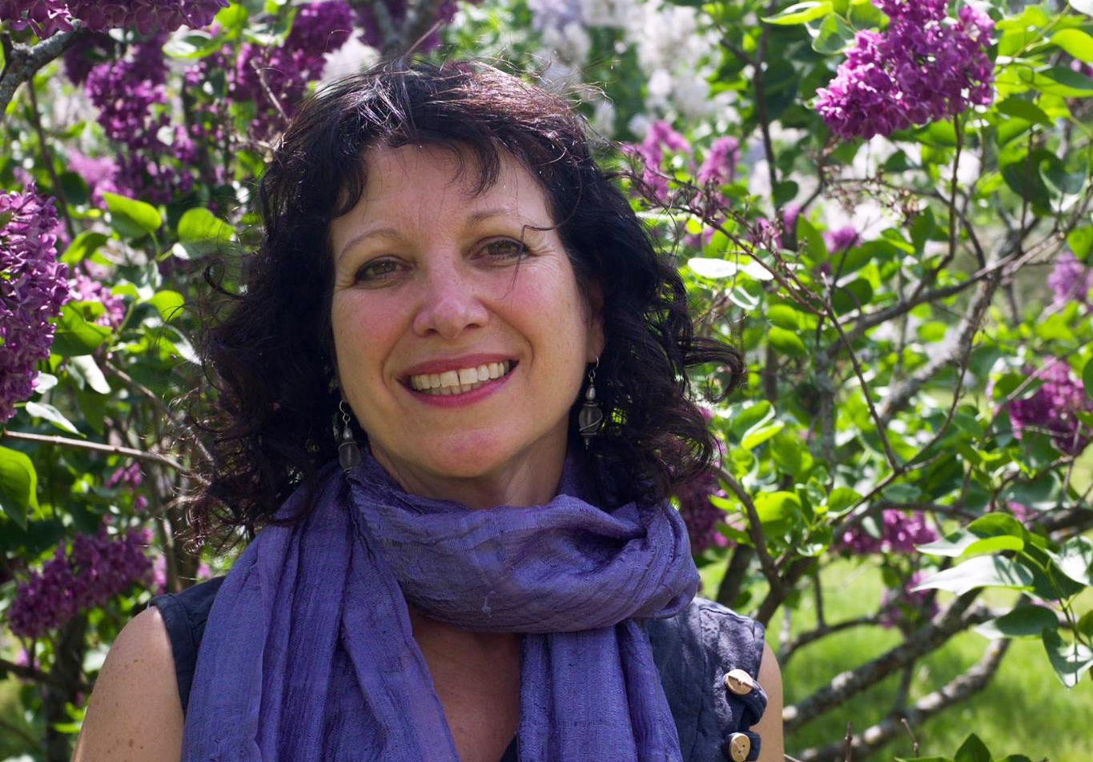
Meet our Keynote Speaker and New UUA Ambassador to the EUU–The Reverend Diane Rollert

In 2006, Rev. Diane Rollert became the 11th settled and first female minister of the Unitarian Church of Montreal since its founding in 1842. She was appointed the new UUA Ambassador to the EUU in 2017.

Diane completed her studies in parish ministry and Masters of Divinity at Harvard Divinity School in 2005, after careers in the online information industry and education.

She was the Canadian Unitarian Council’s 2011 Confluence Lecturer, focusing on post-secularism, and served as minister to the Unitarian Universalist Church of the Philippines while on sabbatical in 2012. She is the first female president of the Christian-Jewish Dialogue of Montreal and serves on the board of the Unitarian Universalist Partner Church Council.

Diane has appeared on television, testified before the National Assembly’s commission on secularism, and has been published in Quebec’s English and French press regarding Bill 60, the proposed Secular Charter, among other issues. She has been a key leader in the fight for religious freedom, having formed a group called Femmes qui croient en la femme (Women Who Believe in Women) and having worked closely with members of the Christian-Jewish Dialogue of Montreal to produce a series of videos celebrating Quebec’s diversity.

Diane is originally from the US and has studied in Mexico and Spain, lived in Luxembourg, and has spent much time over the years with her husband’s family in northern Italy. She has a passion for languages and communication having learned to speak French since she first arrived in Montreal. She also speaks Italian and can often resuscitate her Spanish. She has a great love for the UU communities of the Philippines as well as a strong connection to the Gaspésie where she often lives for several weeks each summer.

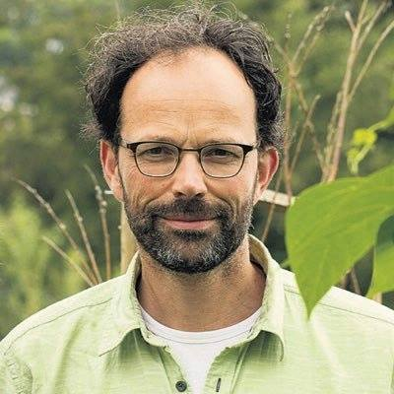
About our Guest
Taco IJzerman, Druid

Taco leads services at NUUF (Netherlands Unitarian Universalist Fellowship) on a regular basis. His thoughtful, earth-based rituals are some of th most popular events in the NUUF fellowship year, connecting us to the 7th Principle “the interconnected web” and the 6th Source. (see box)

“The cycle of the seasons inspires me as a connection to the 'here & now' and as a metaphor for professional and personal development. In 1997 I became a member of OBOD, a modern druid order. Since then I have been walking on a wide path of self-development and a deeper connection with people and nature. It runs through my work and life like a green thread. I have been leading seasonal services in several liberal protestant communities and at NUUF Amsterdam for ten years now.”

Join Taco for a workshop, and if you chose the extended stay option, join him for the Samhain celebration on Sunday evening.

Our 6th source: Spiritual teachings of earth-centered traditions, which celebrate the sacred circle of life and instruct us to live in harmony with the rhythms of nature.

Retreat Program
Friday
15.00-18.00 | Registration |  |  | Reception
18.00-19.30 | Dinner |  |  | Dining facilities
19.55 | Announcements |  |  | Pierre Legrand
20.00 | Opening |  |  | Pierre Legrand
 | Sharing of Joys and Concerns |  |  | Pierre Legrand
 | Ice breaker |  |  | Pierre Legrand
 | Informal get together/  Song Circle |  |  | Bar area/Pierre Legrand
Saturday
7-8.30 | Breakfast |  |  | Dining facilities
8.55 | Announcements |  |  | Pierre Legrand
9.00 | Theme talk part 1 |  |  | Pierre Legrand
10.30 | Coffee break |  |  | Outside main hall
11.00 | Theme talk part 2 |  |  | Pierre Legrand
11.55 | Announcements |  |  | Pierre Legrand
12.00 | Lunch |  |  | Dining facilities
13.30 | Workshop round 1 |  |  | TBA
15.00 | Coffee break |  |  | Outside main hall
15.30 | Workshop round 2 |  |  | TBA
17.00-18.00 | Choir rehearsal |  |  | Pierre Legrand
18.00-19.30 | Dinner |  |  | Dining facilities
19.30 | RE presentations |  |  | Pierre Legrand
After presentations | Variety show |  |  | Pierre Legrand
 | Informal get together/  Song Circle |  |  | Bar area/Pierre Legrand
Important Note: Remember the time change (fall back) Saturday night!

Sunday

When |  | What | Where
7.00-8.30 |  | Breakfast | Dining facilities
9.00-10.00 |  | Choir practice | Pierre Legrand
Before 9.30 |  | Room checkout | Reception
10.00-11.00 |  | Service | Pierre Legrand
11.00 |  | New member ceremony | Pierre Legrand
11.15 |  | Closing | Pierre Legrand
12.00-13.30 |  | Lunch | Dining facilities
Extended Stay Program Sunday afternoon-Monday

Sunday  13.00-15.00 |  | CC Meeting Session 1 | TBA
13.30-15.00 |  | Free time
15.00-15.30 |  | Coffee break | TBA
15.30-18.30 |  | CC Meeting Session 2 | TBA
15.30-17.00 |  | Workshop Taco | TBA
18.00-19.30 |  | Dinner | Dining facilities
20.00-21.00 |  | Samhain Ceremony | TBA
 |  | Informal get together | Bar area
Monday

When |  | What | Where
7.00-8.30 |  | Breakfast | Dining facilities
Before 10.00 |  | Room checkout | Reception

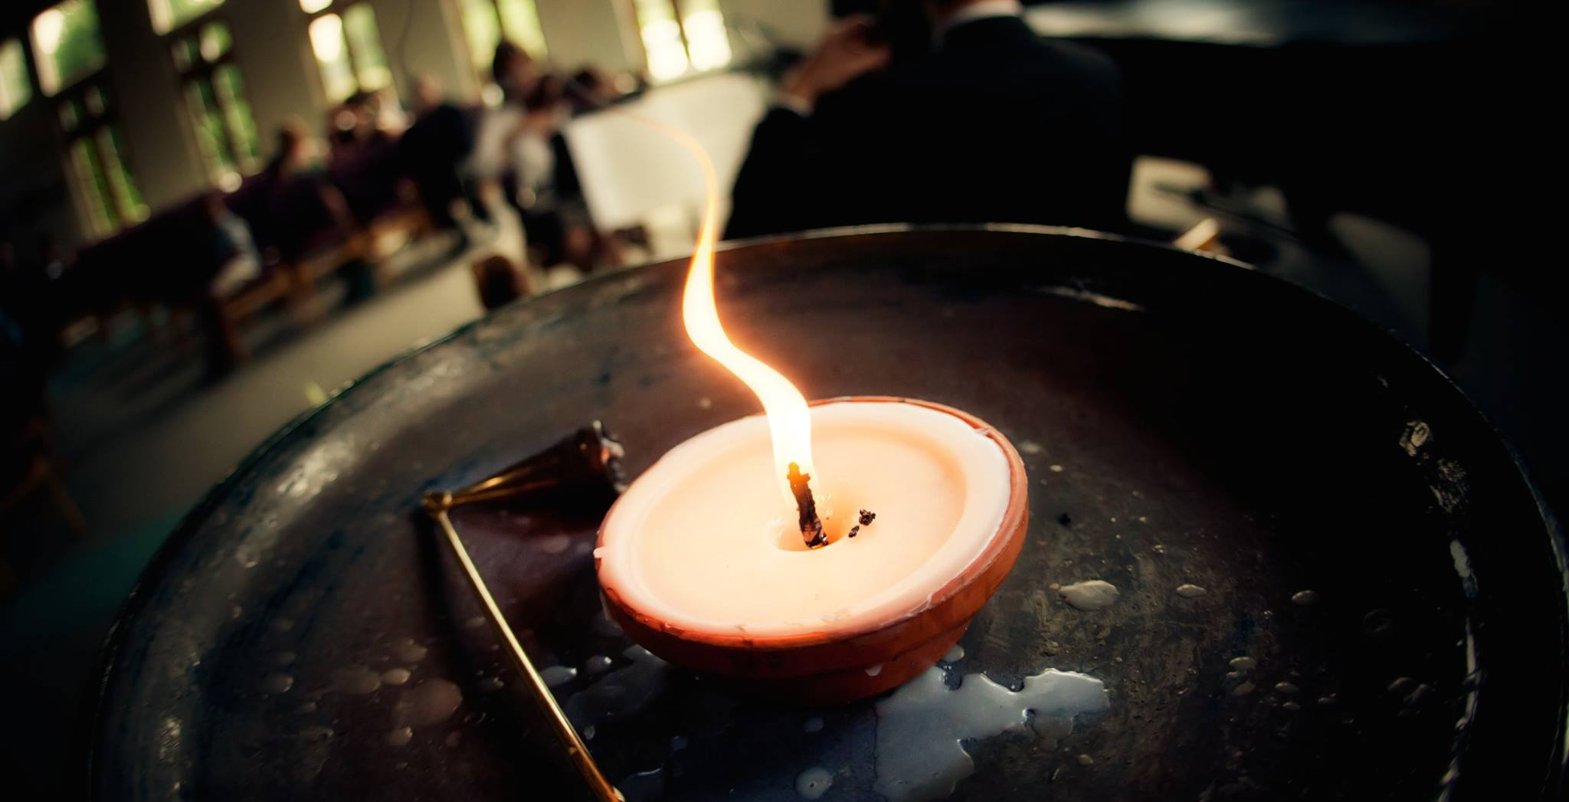
Workshop Descriptions

A selection of the Saturday afternoon workshops. More workshops may be posted by
the reception area.

Heaven and Earth meet in the heart
Taco IJzerman

In the druid ways various aspects of nature and seasonal cycles are used to mirror and inspire our lives. In this workshop we will work with the tree(s) as a metaphor of our position between earth and sky and each other. We'll sing (chant), move, breath, talk and try and become a forest of trees.

Taco Ijzerman is a Druid of the OBOD order. Taco describes his ceremonial work and workshops under the rubric The Green Chapel - Nature as Inspiration, Seasons as Metaphor. Since 2007, Taco has offered ceremonial leadership in municipalities in the central Netherlands and at NUUF. Complementing this work, Taco is a consultant in organic gardening and urban agriculture.

From Ulm to Berlin: Co-hosting Retreats with the German Unitarians
Terri Michos

The recent retreat in Ulm was a magical experience for many. In the wake of its success, many members have expressed interest in the EUU co-hosting the next URfG (German Unitarians) retreat in Berlin in 2019. This workshop will provide a chance to look back at Ulm and forward to Berlin and try to address the concerns of our members so that any development will be as transparent and as democratic as possible.

Participants are welcome to review information about the Ulm Retreat prior to the workshop. See https://www.unitarier.de (in German) and the spring edition of EUUs quarterly magazine, the Unifier.

This workshop will be led by Terri J. Michos, EUU member since 2008. Terri was the workshop coordinator of the EUT2017 in Ulm last June.

Vision and Mission Statements
Bonnie Friedmann

Opening the Welcome Tent Wide –
On Moving from Diversity Statements to True Integration and embracing differences in our communities.
Shulamit Levine-Helleman

While most UU fellowships and the EUU do a good job of welcoming LGBTQIA individuals as full and equal members, we are often not as good at making people of other marginalized communities feel fully welcome and included. In this workshop, we will look at how we can better practice full welcome and inclusion. The workshop leader will present information on some of the ways people feel excluded and lead a discussion on ways we can change and be more welcoming. How can we make sure that people with sensory issues or mobility difficulties or not enough money can fully participate in services and activities? How can we embrace diversity of cultural and ethnic backgrounds? How can we welcome theists and humanists and make sure both feel heard? How can we fully include both US expats and European locals in our fellowships and the EUU? UU culture is richer when we see our multiple identities as a salad bowl, rather than a melting pot. With a salad bowl, we bring all of our unique identities with us, mixed together in a way that enriches all of us with our diversity. Hopefully our discussions will give community organizers tools and ideas to bring back to their own fellowships and to the EUU leadership. The workshop leader has experience in organizing events and communities and actively working on inclusion issues and is herself a member of several marginalized communities.

What is your concept of the meaning of life?
Phil Campbell & Chet Boyers

The purpose of this workshop is to encourage a discussion about the meaning of life, as each of us believes it to be. There is no right or wrong, just an exploration of a serious topic that we all grapple with over our lives. Some of us have a fixed idea, others are aware that this has changed over their lifetimes. The workshop facilitators are Chet Boyers and Phil Campbell, both long time members of the Kaiserslautern UU Fellowship.

Living with the other, living with one another - a discussion about Islam and Islamophobia
Tony Zamparutti & Hajib El Hajjaji

Who are our neighbors? How do Moslems in Europe experience the current political and social climate? How can we live with one another?
The workshop will be hosted by Tony Zamparutti from the Brussels UU Fellowship and led by a local guest, Hajib El Hajjaji, who lives in Verviers close to Spa. Hajib is active in inter-cultural dialogue in Belgium and works with CCIB, an association to promote understanding and to counter Islamophobia. He has provided training on addressing Islamophobia, including at the European Commission. After Hajib's presentation, we will have an open discussion on Islam, Islamophobia and ways to better understanding.

Torah Study
Neil Johnson

Parts of the Old Testament (known in Jewish tradition as the written Torah) can be problematic for modern sensibilities, perhaps no more so than those concerning capital punishment. The Torah mentions nearly two dozen capital offenses. Yet the rabbis in Talmud (the oral Torah) said that a court that executes one person in seventy years is a cruel one. How does this work? How can so many capital crimes lead to so few executions? And if the death penalty is never applied why establish capital crimes in the first place?

To explore these questions we will study extracts from the Mishna Torah, the first compendium of Jewish law as laid out in the Talmud, written by Maimonides in the 12th century. The Talmud introduces a surprisingly humanistic vision of the legal process, in many cases more “enlightened” than our courts today. Hopefully this workshop will make the Old Testament a little more user friendly.

Who are we and how do we explain it? UU Elevator Speeches 101
Darrel Moellendorf

How many times have you confronted that dreaded question from an acquaintance, What is Unitarian Universalism? If you are not prepared it can leave you fumbling and mumbling, and certainly not making a very strong impression. In this practical and fun workshop we will work on developing snappy and informative statements of our faith tradition so that next time we are prepared to face the question with aplomb.
Please bring: paper and pencil

Darrel Moellendorf has been a UU for over 10 years and is a member of the Wiesbaden UU Fellowship.

Yoga for everybody
Caroline von Westernhagen

EUU Membership Information

European Unitarian Universalists is a unique organization that is made up of affiliated fellowships and actual members.

Members do not have to be part of a formal “bricks and mortar” European fellowship, but can also be members or adherents of the Church of the Larger Fellowship, a UU church, fellowship, chapel or other organization outside of Europe, or be an “at large” or solitary from anywhere. Membership in the EUU does not conflict with membership in any other Unitarian or Universalist community. What it does do is provide you with a community that meets twice a year physically and has a variety of other real and virtual contact moments throughout the rest of the year.

In addition to the networking, personal contacts and retreat opportunities, membership also gives you a chance to participate in some of the social justice and other activities that the EUU sponsors or is engaged in. You will hear more about some of those over the weekend.

If you would like more information about becoming a member or what membership entails, please drop by the Membership Welcoming table near the registration area. Or speak to EUU Vice-president Gail Rosencrance over the weekend.

There will be a brief membership ceremony on Sunday for those who decide they would like to become a member of the EUU.

Even if you decide not to become a member, we are still glad to see you and would like to see you again.

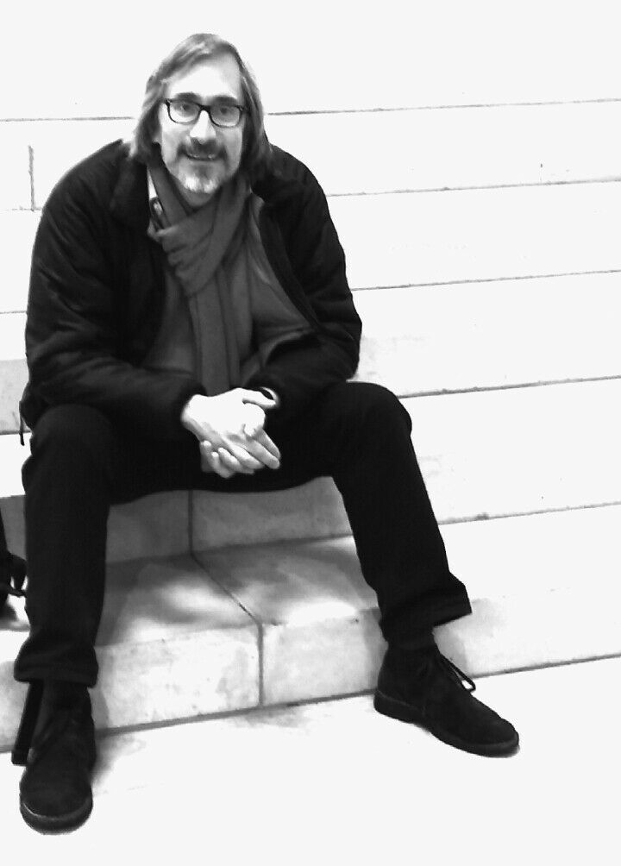
EUU Pledge Drive
A message from Tony Zamparutti
Your pledge supports EUU's work!
The annual pledge drive supports Social Action, Religious Exploration for young people and for the development of our local fellowships. And the EUU's 2017 Pledge Drive is reaching its close. Many EUU members have pledged - but some have not done so yet, and we have not yet reached our annual goal, 8000 Euros.

You can still make your pledge at Spa - come to the pledge drive on Saturday evening 19.00-19.30. And come by if you haven't yet paid a pledge you made earlier in the year. Or talk to our Pledge Drive Coordinator, Tony Zamparutti, anytime during the retreat.

P.S. You can also pledge via EUU's online form: www.tinyurl.com/euupledge

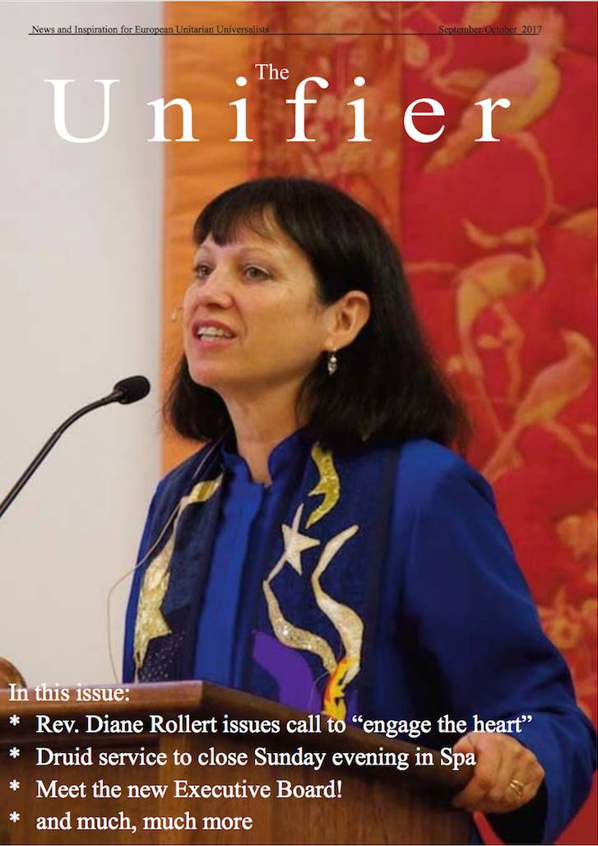
Unifier seeks contributors
The EUU publication, The Unifier is one of the major ways that news and views are exchanged among the membership. It serves a crucial role in what binds us together and gives you a chance to contribute to that feeling of togetherness.

One of the most important aspects of The Unifier is reporting on retreat-related activities. Reports are needed about the theme talk, the workshops, the Sunday service, and so forth. Over the course of the weekend, you will be reminded several times about the important role that you can play in helping to fill The Unifier with your take on things. You don’t have to wait to be reminded, however. Simply find the editor and tell them enthusiastically that you will be more than pleased to provide a short report on one aspect or another of the weekend.

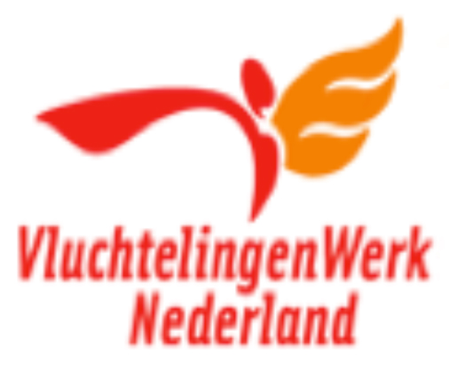
The Sunday Offering
VluchtelingenWerk Nederland
Dutch Council for Refugees
The text below is adapted from the Vluchtelingenwerk English language info page https://www.vluchtelingenwerk.nl/english

Refugees have a right to a fair asylum procedure, and subsequently access to adequate housing, education, health care and work. The Dutch Council for Refugees is an independent, non-governmental organization that defends those rights.

What they do
With 13.500 volunteers and a few hundred paid employees VWN offers refugees practical support during their asylum procedure and their integration in the Dutch society. In addition, they provide members of the Parliament with information concerning refugee issues and policy and we carry an active lobby for refugee rights. Another important part of the work is to supply information and advice to asylum lawyers. VWN also develop various projects to promote the integration of refugees in the Netherlands. Furthermore, they are committed to increasing public support for refugees.

The organization
With one National Office, 8 regional offices, and 310 local branches they are active in the majority of all local council districts. The National Office supports the regional and local branches with advice, education, and information.

Their international activities
The Dutch Council for Refugees, wanting the best for refugees not only in the Netherlands but also in other countries, aims to share its knowledge and experience with NGOs in other countries, particularly the countries at the external borders of the EU.

ECRE: influencing the European agenda
They are a member of the European Council on Refugees and Exiles (ECRE). With 90 member organizations in 38 countries ECRE aims to influence the European agenda to promote the protection and integration of all individuals who seek refuge and protection within Europe.

info@vluchtelingenwerk.nl. Or call: (020) 346 72 00.
Unitarian Universalist
Principles and Sources

Principles

We, the member congregations of the Unitarian Universalist Association, covenant to affirm and promote:

The inherent worth and dignity of every person;
Justice, equity, and compassion in human relations;

Acceptance of one another and encouragement to spiritual growth in our congregations;

A free and responsible search for truth and meaning;

The right of conscience and the use of the democratic process within our congregations and in society at large;

The goal of world community with peace, liberty, and justice for all;

Respect for the interdependent web of all existence of which we are a part.

Sources

The living tradition which we share draws from many sources:

Direct experience of that transcending mystery and wonder, affirmed in all cultures, which moves us to a renewal of the spirit and an openness to the forces which create and uphold life;

Words and deeds of prophetic women and men which challenge us to confront powers and structures of evil with justice, compassion, and the transforming power of love;

Wisdom from the world's religions which inspires us in our ethical and spiritual life;

Jewish and Christian teachings which call us to respond to God's love by loving our neighbors as ourselves;

Humanist teachings which counsel us to heed the guidance of reason and the results of science, and warn us against idolatries of the mind and spirit;

Spiritual teachings of earth-centered traditions which celebrate the sacred circle of life and instruct us to live in harmony with the rhythms of nature.

Grateful for the religious pluralism, which enriches and ennobles our faith, we are inspired to deepen our understanding and expand our vision. As free congregations we enter into this covenant, promising to one another our mutual trust and support.

EUU Team Contacts

President: Carolyn Burlingame-Goff
President@europeanuu.org

Vice President: Gail Rosecrance
VicePresident@europeanuu.org

Secretary: Bonnie Friedmann
Secretary@europeanuu.org

Treasurer: Tom Sievers
Treasurer@europeanuu.org

EUU Ambassador
Reverend Diane Rollert

RE Coordinator: Jeanette Wild-Sievers
YouthRE@europeanuu.org

Unifier Editor (Submit to newsletter)
Unifier@europeanuu.org

Member Database
(Subscribe to newsletter)
Database@europeanuu.org

Social Action: Jodi Stolzenbach and Diana Smith
SocialAction@europeanuu.org

View this info or download the PDF at the NUUF website www.nuuf.nl.

